HABITS OF A MULTIPLYING DISCIPLE: DISCOVER

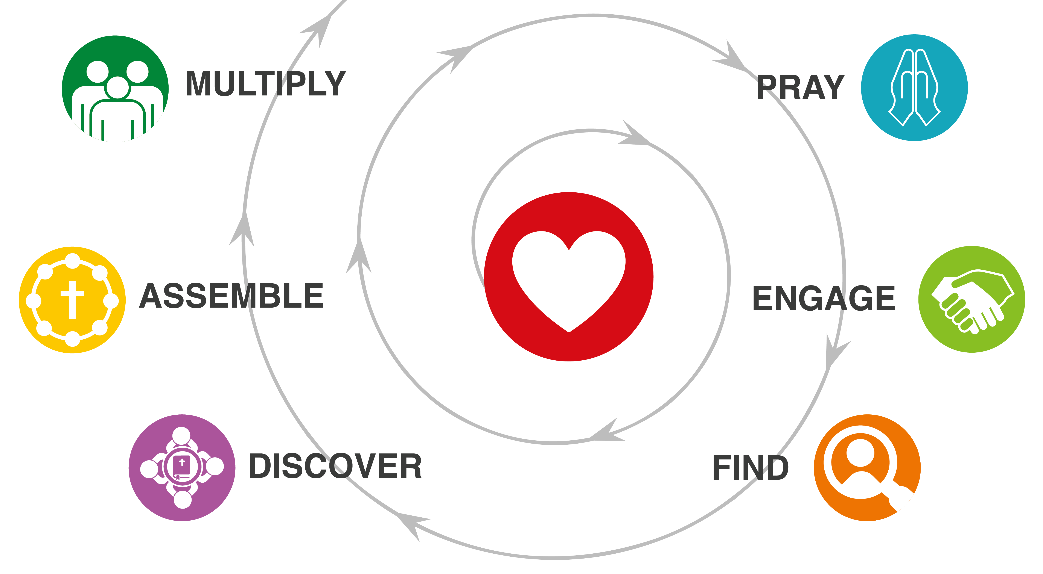
HOMEWORK DISCUSSION
- What stood out to you from John 6:44-46?
- What did God invite you to do? (Your “I will…”) How did it go?
- How did it go probing spiritual openness with two people?

EXPERIENCING DISCOVERY GROUP
- How did you do obeying and sharing what you learned last week?
- What are you thankful for?
- What is the biggest challenge or problem you are facing today?
- Do you know someone you could serve this week?

Read, Reread, Retell
- What is God saying… about Himself? people? the life he invites us to live?
- If this is God speaking what will you do about it?
- With whom will you share what you learned this week?
Try the format right now! Read, reread and paraphrase Mark 2:13-17. Then ask and answer questions 5, 6, and 7.

WHAT ARE THE BENEFITS AND CHALLENGES OF DISCOVERY GROUPS?
Make and discuss two lists.
- What are the benefits of the Discovery Group model?
- What are the challenges of using this way of doing a discipleship-based group?

THE PRINCIPLES OF MULTIPLICATIVE GROUPS
Discovery Groups are more than a way of doing small groups. They are part of a larger strategy of seeing the good news of Jesus permeate the cultures, families, and networks in our communities. Discuss these principles. Why are each of them critically important?
- Stick with one passage. Why?
- Do not display your knowledge and expertise in groups. Why?
- Pass off facilitation almost immediately. Why?
- Start groups, if at all possible, on their turf not your turf. Why?
- Anyone can ask, “Where did you see that in this passage?” Why?

YOUR ASSIGNMENT
- Do a 3-Column Study on Acts 2:38-47.
- Lead a Discovery Group with several others using the 7 questions.

What does it say?
(Write the text word-for-word.)

What does it mean?
(Write it in my own words.)

What must I do to obey?
(My “I will…” statement.)

With whom will I share?

